VALUATION REPORT
Of

M/s. J. M. Mhatre Infra Pvt. Ltd.

At
N. A. Plot of Land bearing Survey No. 55, Hissa No. 2/A/1, Survey No. 68, Hissa No. 3/A/1, Survey No. 11, Survey No. 12, Hissa No. 1-B1, Survey No. 56, Hissa No. 6, Near Indospace Logistic Park, Khalapur – Pen Road, Village – Ajivali, Taluka - Khalapur, District – Raigad - 410203

For

BANK OF BARODA – NARIMAN POINT PANVEL

BY

Manoj Kumar Sharma
Govt. Approved Valuer

To,
Bank of Baroda
Branch – NARIMAN POINT PANVEL

VALUATION REPORT

(In Respect Of N.A. Plot)
Ref.: UCVLLP/BOB/5362 Date: 01-April-2024

I. | GENERAL
1. | Purpose for which the valuation is made
2. | a) | Date of inspection
 | b) | Date on which the valuation is made
3. | List of documents produced for peruse
 | Old Valuation Report
 | Other Documents
4. | Name of the owner(s) and his /their address (es)  with Phone no. (details of share of each owner in case of joint ownership)
 | Brief description of the property (Including leasehold/ freehold etc.)
a | Total Lease period & remaining period (if  leasehold)
6. | Location of property
 | a) Plot No. / Survey No.
 | b) Door No
 | c) T. S. No. / Village
 | d) Ward / Taluka
 | e) Mandal / District
7. | Postal address of the property
8. | City / Town
 | Residential Area
 | Commercial Area
 | Industrial Area
9. | Classification of the area
 | i) | High / Middle / Poor
 | ii) | Urban / Semi Urban / Rural
10 | Coming under Corporation limit / Village  Panchayat / Municipality
11 | Whether covered under any State / Central Govt.  enactments (e.g. Urban Land Ceiling Act) or notified under agency area / scheduled area / cantonment area

12 |  |  | In case it is an agricultural land, any conversion  to house site plots is contemplated
13 |  |  | Dimensions/ Boundaries of the property |  |  |  |  |  | A |  |  |  | B
 |  |  |  |  |  |  |  |  | As per the Deed |  |  |  | Actuals
 |  |  | North
 |  |  | South
 |  |  | East
 |  |  | West
 | 13.2 |  | Latitude, Longitude and Coordinates of the site
 | 14 |  | Extent of the site
 | 15 |  | Extent of the site considered for valuation (least of 13 A & 13B)
 | 16 |  | Whether occupied by the owner / tenant? If  occupied by tenant, since how long? Rent received per month.
 | II. |  | CHARACTERISTIGS OF THE SITE
 | 1. |  | Classification of locality
 | 2. |  | Development of surrounding areas
 | 3. |  | Possibility of frequent flooding / sub-merging
 | 4. |  | Feasibility to the Civic amenities like school,  hospital, bus stop, market etc.
 | 5. |  | Level of land with to topographical conditions
 | 6. |  | Shape of land
 | 7. |  | Type of use to which it can be put
 | 8. |  | Any usage restriction
 | 9. |  | Is plot in town planning approved layout?
 | 10 |  | Corner plot or intermittent plot?
 | 11 |  | Road facilities
 | 12 |  | Type of road available at present
 | 13 |  | Width of road — is it below 20 ft. or more than 20 ft.
 | 14 |  | Is it a land — locked land?
 | 15 |  | Water potentiality
 | 16 |  | Underground sewerage system
 | 17 |  | Is power supply available at the site?
 | 18 |  | Advantage of the site
 | 19 |  | Special remarks, if any, like threat of  acquisition of land for public service purposes, road widening or applicability of CRZ provisions etc. (Distance from sea-coast / tidal level must be incorporated)
 | Part — A (Valuation of land)
 | 1. |  | Size of plot
 | 2. |  | Total extent of the plot
 | 3. |  | Prevailing market rate (Along with details  Preference of atleast two latest deals/transactions with respect to adjacent properties in the areas)
 | 4. |  | Guideline rate obtained from the Registrar's  Office (an evidence thereof to be enclosed)
 | 5. |  | Assessed / adopted rate of valuation
 | 6. |  | Estimated value of land
 | Part- B (Valuation of Building)
 |  |  | Building Structure : Not Applicable
 | 1. |  | Technical details of the building
 |  |  | a) |  | Type of Building (Residential /Commercial /  Industrial)
 |  |  | b) |  | Type of construction (Load bearing / RCC /  Steel Framed)
 |  |  | c) |  | Year of construction
 |  |  | d) |  | Number of floors and height of each floor  including basement, if any
 |  |  | e) |  | Plinth area floor-wise
 |  |  | f) |  | Condition of the building
 |  |  |  |  | i) |  | Exterior - Excellent, Good, Normal, Poor
 |  |  |  |  | ii) |  | Inferior - E excellent, Good, NormaI, Poor
 |  |  | 9) |  | Date of issue and validity of layout of  approved map / plan
 |  |  | h) |  | Approved map / plan issuing authority
 |  |  | i) |  | Whether genuineness or authenticity of approved map /pIan is verified
 |  |  | j) |  | Any other comments on authenticity of approved plan and construction as per the approved plan
 | S. No. |  |  | Description
 | 1. |  |  | Foundation
 | 2. |  |  | Superstructure
 | 3. |  |  | Joinery / Doors & Windows (please furnish details about size of frames, shutters, glazing, fitting etc. and specify the species of timber)
 | 5. |  |  | RCC works
 | 6. |  |  | Plastering
 | 7. |  |  | Flooring, Skirting, dadoing
 | 8. |  |  | Special finish as marble, granite, wooden paneling, grills, etc.
 | 9. |  |  | Roofing including weather proof course
 | 10. |  |  | Drainage
 | 11. |  |  | Compound wall
 |  |  |  | Height
 |  |  |  | Length
 |  |  |  | Type of construction
 | 12. |  |  | Electrical installation
 |  |  |  | Type of wiring
 |  |  |  | Class of fittings (superior / ordinary /poor)
 |  |  |  | Number of light points
 |  |  |  | Fan points
 |  |  |  | Spare plug points
 |  |  |  | Any other item
 |  | 13. |  | Plumbing installation
 |  |  |  | a) |  | No. of water closets and their type
 |  |  |  | b) |  | No. of wash basins
 |  |  |  | c) |  | No. of urinals
 |  |  |  | d) |  | No. of bath tubs
 |  |  |  | e) |  | Water meter, taps, etc.
 |  |  |  | f) |  | And other fixtures

 | Part C – (Extra Items |  | (Amount in Rs.)
1. | Portion
2. | Ornamental front door
3. | Sit out/ Verandah with steel grills
4. | Overhead water tank
5. | Extra steel/ collapsible gates
 | Total

Part D-(Amenities) (Amount in Rs.)
1. | Wardrobes
2. | Glazed tiles
3. | Extra sinks and bath tub
4. | Marble / ceramic tiles flooring
5. | Interior decorations
6. | Architectural elevation works
7. | Paneling works
8. | Aluminum works
9. | Aluminum hand rails
10. | False ceiling
 | Total

 | Part E -(Miscellaneous) (Amount in Rs.)
1 | Separate toilet room
2 | Separate lumber room
3 | Separate water tank/ sump
4 | Trees, gardening
 | Total

 | Part F- (Services) (Amount in Rs.) (Amount in Rs.)
1. | Water supply arrangements
2. | Drainage arrangements
3. | Compound wall
4. | C. B. deposits, fittings etc.
5. | Pavement
 | Total

Total abstract of the entire property

Part- A | Land
Part- B | Building
Part- C | Extra Items
Part- D | Amenities
Part- E | Miscellaneous
Part- F | Services
 | Total

(In Words: Only)

MARKETIBILITY:

Present Fair Market Valuation:

Factors considered for valuation :

SUMMARY OF VALUATION (For Land):
Fair Market Value
Realizable Value
Distress Value
Value as per circle rate

(Valuation: Here the approved valuer should discuss in detail his approach to valuation of property and indicate how the value has been arrived at, supported by necessary calculations. Also, such aspects as: i) Satiability ii) Likely rental values in future in iii) Any likely income it may generate, may be discussed).

As a result of my appraisal and analysis, it is my considered opinion that the present Fair Market Value of the above property in the prevailing condition with aforesaid specifications is Rs. 13,60,50,000/- (Rupees Thirteen Crore Sixty Lakh Fifty Thousand Only). The realizable value of the above property as of Rs. 12,24,45,000/- (Rupee Twelve Crore Twenty Four Lakh Forty Five Thousand Only) and the distress value is Rs. 10,88,40,000/- (Rupees Ten Crore Eighty Eight Lakh Forty Thousand Only).

Place : Thane.
Dated: 01/04/2024

(MANOJ KUMAR SHARMA)
Govt. Valuer & Chartered Engineer
Panel Valuer of Bank of Baroda
(IBBI/RV/07/2019/11044)

The property was inspected by our Engineer, Mr. Prashant Pakhale detailed in the Valuation
Report dated 28/03/2024. We are satisfied that the fair and reasonable market value of the
property is Rs. 13,60,50,000/- (Rupees Thirteen Crore Sixty Lakh Fifty Thousand Only)

Signature
(Name of Branch Official with seal)

Assumptions/Remark:
- Details of the mortgages are with landlord/Owner.
- We have finalized the report on the basis of site visit and copy of: Old Valuation Report only However, we have not been provided with Sale agreement, Index-II, approved plan, N.A order, title report, 7/12 extract, etc. for verification purpose.
- We have taken all Technical details from old valuation report.
- The subject property is N.A. Land.
- The property is Levelled Plain Land & irregular shaped land.
- No name board was displayed at site.
- It is an open plot along with temporary shed structure
- Separate demarcation of each plot was not available. The plots are shown to us by Mr. Prasad Ghansolikar (Employee of M/s. JMMI Pvt. Ltd.). Exact identification of each plot was not possible, hence whether plots are continuous is not sure.
- We consider the area given in the Old Valuation Report, declared by the party and submitted for registration with the government authorities as final for valuation purpose. Any area that is not stated in the Old Valuation Report is not considered for valuation unless the area is measured by us in which case that may be considered for valuation purpose.
- The real estate market in India lacks transparency with limited availability of authentic data. The actual market value may differ significantly from the value that is officially documented. We understand that market survey among property brokers; actual sellers, developers and other persons dealing with properties would give us a fair indication of market trends. We have therefore based our valuation on verbal feedback received from such market sources.
- Our valuation is based on our experience and knowledge and this is an opinion only and does not stand as a guarantee for the value it can fetch if disposed, due to any emergency.
- We presume that the legal documents pertaining to the ownership of the above said property has been verified by the bank/party. We do not certify the authenticity of the documents presented to us for valuation and assume them to be correct. This report does not certify valid or legal or marketable title of any of the parties over the property. Our report does not cover verification of ownership, title clearance, or legality and subject to adequacy of engineering / structural design.
- The Valuation given is on the base of present market value of the similar unit which is in line with the rules and regulations of the concerned authority and if the construction is carried out as per the approved plans of the appropriate authority.
- It should be noted that our value assessments are based upon the facts and evidence available at the time of assessment and must be periodically reviewed.
- Valuer is not required to give testimony or appear in court or in any Government office by reason of this report as it is outside the scope of the assignment.
- The report is issued at the specific request of the party for specific purpose and the said report is not valid if the purpose of use and party is different.
- The value given in our report is the estimate of the Fair Market value of the property as on date, considering various aspects of the property like amenities in projects, locational advantages, demand and supply equation in the property, outside view, Vashtu aspects etc. which is generally more or less than the Government ready reckoner value.

I hereby declare that:
- The information furnished is my valuation report dated 01/04/2024 is true and correct to the best of my knowledge and belief and I have made an impartial and true valuation of the property.
- I have no direct or indirect interest in the property valued.
- Our Engineer Mr. Prashant Pakhale has inspected the property on 28/03/2024.
- I have not been convicted of any offence and sentenced to a term of imprisonment.
- I have not been found guilty of misconduct in my professional capacity.
- I have read the Handbook on policy Standards and procedure for Real Estate valuation, 2011 of the IBA and this report is in conformity to the “Standard” enshrined for valuation in the Part-B of the above handbook to the best of my ability.
- I have Read the International Valuation Standards (IVS) and the report submitted to the Bank of the respective asset class is in conformity to the “Standard” as enshrined for valuation in the IVS in “General standard” and “Asset Standards” as applicable.
- I abide by the Model Code of Conduct for empanelment of valuer in the Bank. (Annexure III-A Signed Copy of Same to be taken and kept along with this declaration).
- I am registered under Section 34 AB of the Wealth Tax Act, 1957.
- I am the proprietor / partner / authorized official of the firm / company, who is competent to sign this valuation report.
- Further, I hereby provide the Following information.

Sr.No. | Particulars | Valuer comment
1. | Background information of the asset being valued
2. | Purpose of valuation and appointing authority
3. | Identity of the valuer and any other experts involved in the valuation.
4. | Disclosure of valuer interest or conflict, if any
5. | Date of appointment, valuation date and date of report,
6. | Inspections and/or investigation undertaken,
7. | Nature and sources of the information used or relied upon,
8. | Procedure adopted in carrying out the valuation and valuation standard followed,
9. | Restriction on use of the report, if any,
10. | Major factors that were taken into account during the valuation,
11. | Caveats, limitation and disclaimers to the extent they explain or elucidate the limitations faced by valuer, which shall not be for the purpose of limiting his responsibility for the valuation report.

MODEL CODE OF CONDUCT FOR VALUERS
{Adopted in line with Companies (Registered Valuers and Valuation Rules, 2017)}
All valuers empanelled with bank shall strictly adhere to the following code of conduct:

Integrity and Fairness
1. A valuer shall, in the conduct of his/its business, follow high standards of integrity and fairness in all his/its dealings with his/its clients and other valuers.
2. A valuer shall maintain integrity by being honest, straightforward, and forthright in all professional relationships.
3. A valuer shall endeavour to ensure that he/it provides true and adequate information and shall not misrepresent any facts or situations.
4. A valuer shall refrain from being involved in any action that would bring disrepute to the profession.
5 A valuer shall keep public interest foremost while delivering his services.

Professional Competence and Due Care
6. A valuer shall render at all times high standards of service, exercise due diligence, ensure proper care and exercise independent professional judgment.
7. A valuer shall carry out professional services in accordance with the relevant technical and professional standards that may be specified from time to time
8. A valuer shall continuously maintain professional knowledge and skill to provide competent professional service based on up-to-date developments in practice, prevailing regulations/guidelines and techniques.
9. In the preparation of a valuation report, the valuer shall not disclaim liability for his/its expertise or deny his/its duty of care, except to the extent that the assumptions are based on statements of fact provided by the company or its auditors or consultants or information available in public domain and not generated by the valuer.
10. A valuer shall not carry out any instruction of the client insofar as they are incompatible with the requirements of integrity, objectivity and independence.
11. A valuer shall clearly state to his client the services that he would be and competent to provide the services for which he would be relying on other valuers or professionals or for which the Independence and Disclosure of Interest.
12. A valuer shall act with objectivity in his/its professional dealings by ensuring that his/its decisions are made without the presence of any bias, conflict of Interest, coercion, or undue influence of any party, whether directly connected to the valuation assignment or not.
13. A valuer shall not take up an assignment If he/it or any of his/its relatives or associates is not independent in terms of association to the company.
14. A valuer shall maintain complete independence in his/its professional relationships and shall conduct the valuation Independent of external influences.
15. A valuer shall wherever necessary disclose to the clients, possible sources of conflicts of duties and interests, while providing unbiased services.
16. A valuer shall not deal in securities of any subject company after any time when he/it first becomes aware of the possibility of his/its association with the valuation, and in accordance with the Securities and Exchange Board of India (Prohibition of Insider Trading) Regulations, 2015 or till the time the valuation report becomes public, whichever is earlier.
17. A valuer shall not indulge in "mandate snatching" or offering "convenience valuations" in order to cater to a company or client's needs.
18. As an independent valuer, the valuer shall not charge success fee (Success fees may be defined as a compensation incentive paid to any third party for successful closure of transaction. In this case, approval of credit proposals).
19. In any fairness opinion or independent expert opinion submitted by a valuer, if there has been a prior engagement in an unconnected transaction, the valuer shall declare the association with the company during the last five years.
Confidentiality
20. A valuer shall not use or divulge to other clients or any other party any confidential information about the subject company, which has come to his/its knowledge without proper and specific authority or unless there is a legal or professional right or duty to disclose.
Information Management
21. A valuer shall ensure that he/ it maintains written contemporaneous records for any decision taken, the reasons for taking the decision, and the information and evidence in support of such decision. This shall be maintained so as to sufficiently enable a reasonable person to take a view on the appropriateness of his/its decisions and actions.
22. A valuer shall appear, co-operate and be available for inspections and investigations carried out by the authority, any person authorised by the authority, the registered valuers organisation with which he/it is registered or any other statutory regulatory body.
23. A valuer shall provide all information and records as may be required by the authority, the Tribunal, Appellate Tribunal, the registered valuers organisation with which he/it is any registered, u other statutory regulatory body.
24. A valuer while respecting the confidentiality of information performing professional acquired during the course of services, shall maintain proper working papers for a period of three years or such longer period as required in its contract for a specific valuation, for production before a regulatory authority or for a peer review. In the event of a pending case before the Tribunal or Appellate Tribunal, the record shall be maintained till the disposal of the case.

Gifts and hospitality:
25. A valuer or his/its relative shall not accept gifts or hospitality which undermines or affects independence as a valuer.
Explanation. - For the purposes of this code the term 'relative' shall have the same meaning as defined in clause (77) of Section 2 of the Companies Act, 2013 (18 of 2013)
26. A valuer shall not offer gifts or hospitality or a financial or any other advantage to a public servant or any other person with a view to obtain or retain work for himself/ itself, or to obtain or retain an advantage in the conduct of profession for himself/ itself.
Remuneration and Costs.
27. A valuer shall provide services for remuneration which is charged in a transparent manner, is a reasonable reflection of the work necessarily and properly undertaken and is not inconsistent with the applicable rules.
28. A valuer shall not accept any fees or charges other than those which are disclosed in a written contract with the person to whom he would be rendering service.
Occupation, employability and restrictions.
29. A valuer shall refrain from accepting too many assignments, if he/it is unlikely to be able to devote adequate time to each of his/ its assignments.
30. A valuer shall not conduct business which in the opinion of the authority or the registered valuer organisation discredits the profession.

Place : Thane.
Dated: 01/04/2024

(MANOJ KUMAR SHARMA)
Govt. Valuer & Chartered Engineer
Panel Valuer of Bank of Baroda
(IBBI/RV/07/2019/11044)

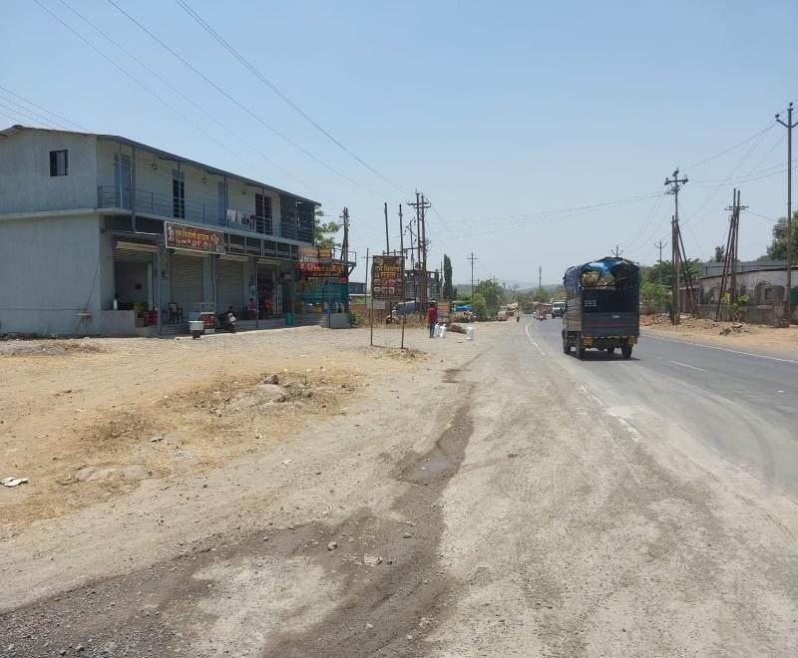
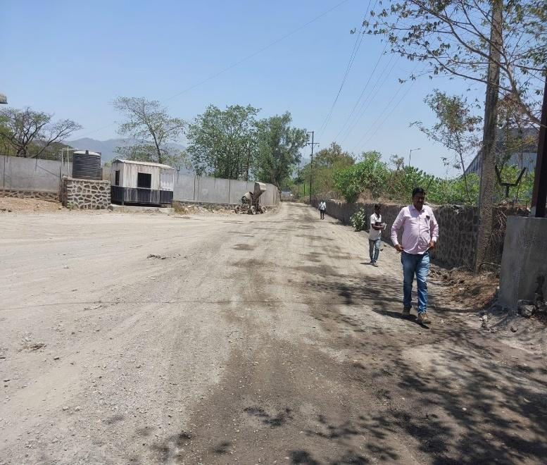
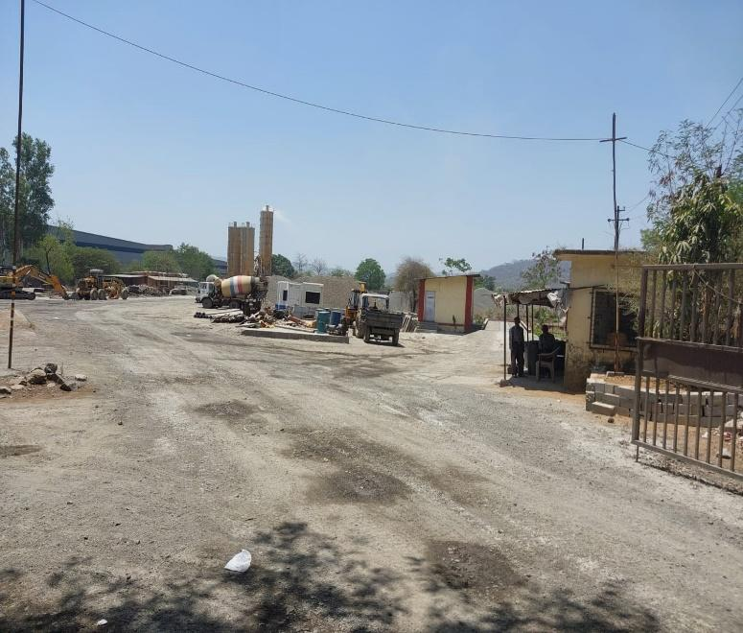
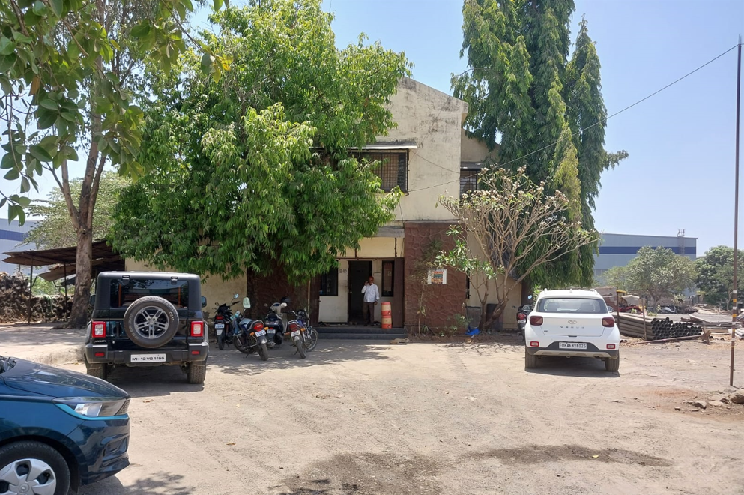
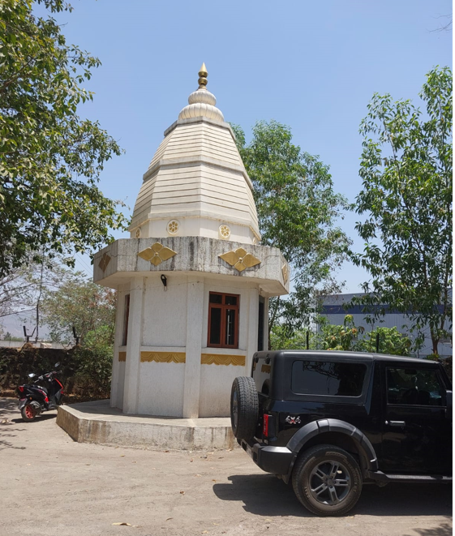
Photographs:
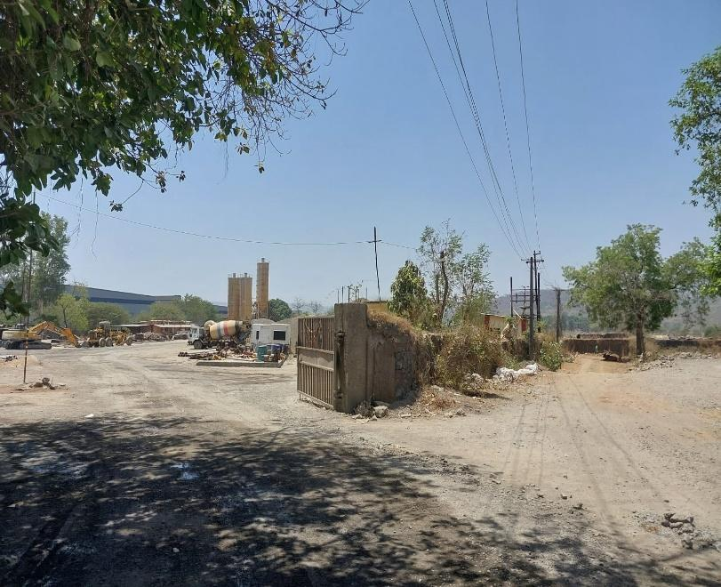

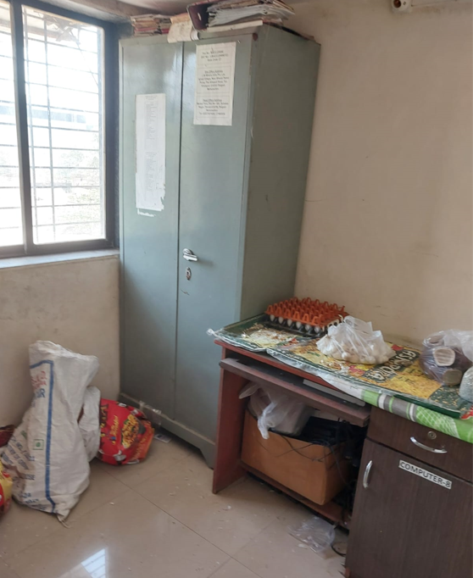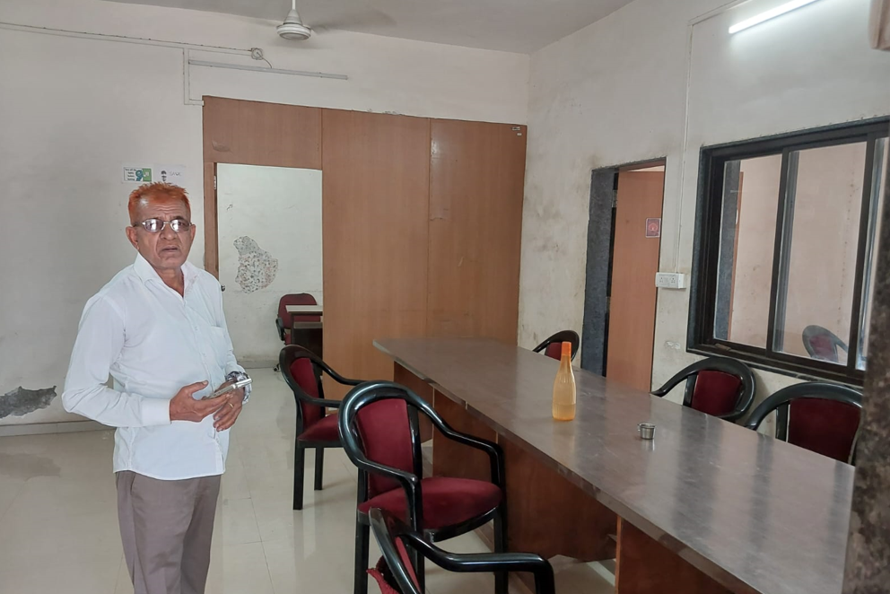

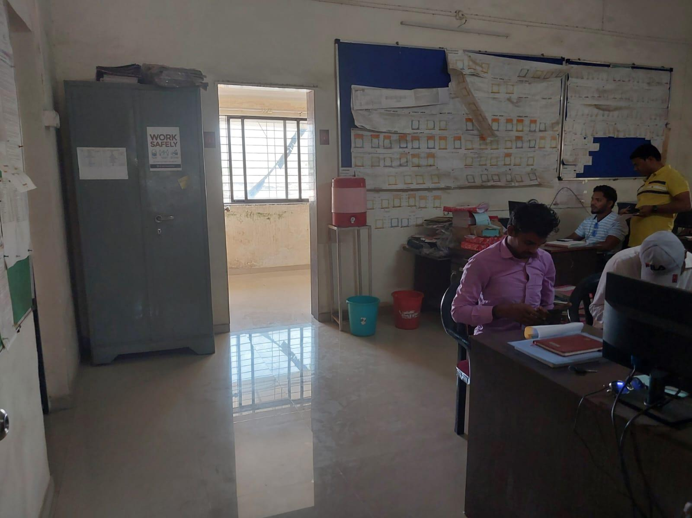

Location:
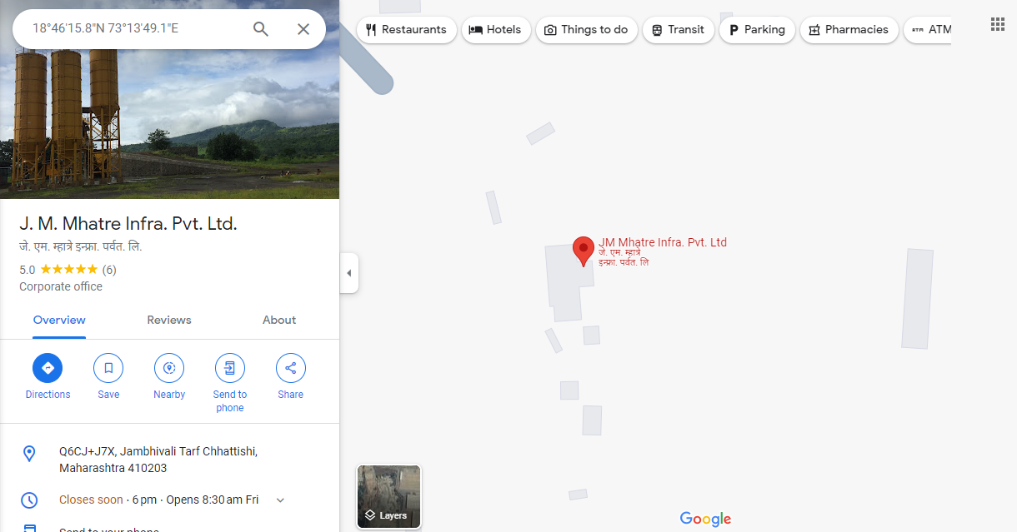

Ready Reckoner:
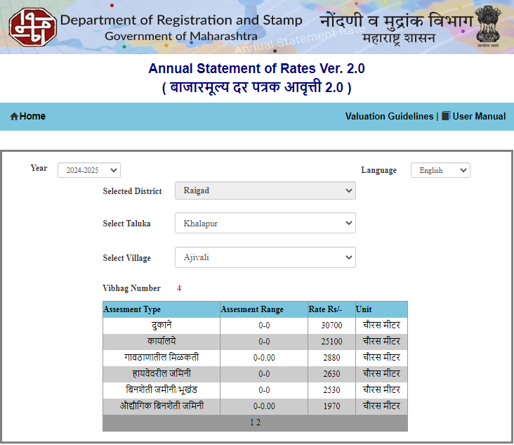
Price Indicators:

